

Royal Education Society’s
College of Computer Science and Information Technology, Latur.

Affiliated to
Swami Ramanand Teerth Marathwada University, Nanded.

A Project Synopsis

On

Agriculture Equipment Rental Management System WEBSITE

Submitted for the award of degree of
Master Of Computer Application

By:

Pandhre Krushna Chandrakant (KZ20482)
In
Academic Year: 2025 - 2026

Dr.D.H.Mahamuni Dr. V.V. Bhosale

Project Guide Head of Department

Table of Content

Sr. No. | Contents | Page No.
1. | Abstract | 3
2. | Introduction of Project | 4
3. | Project Module | 5
4. | Project Plan (Gantt chart) | 6
5.. | Project Requirement | 7
6. | E-R Diagram | 8
7. | Data Flow Diagram (DFD) | 9
8. | Conclusion | 10
9. | Bibliography | 11

Abstract:

The Agriculture Equipment Rental Management System is developed to provide farmers with an easy way to rent agricultural equipment online. Farmers can search and select equipment based on type, availability, and rental duration through a web browser. This system reduces the need for manual work and physical visits to rental centers. It helps farmers save time and cost while accessing modern farming equipment. The project is developed using HTML, CSS, JavaScript, and SQL for effective database management.

Introduction:

An Agriculture Equipment Rental Management System is an online platform where farmers can view and rent agricultural equipment through the internet. Users can browse different types of equipment such as tractors, harvesters, and tools based on their requirement. The system allows farmers to check availability, rental duration, and cost before booking. This project manages equipment details, user information, and rental orders online. It helps farmers save time, reduce effort, and avoid visiting rental centers physically.

Project Module:
- LOG IN Module:

This module provides secure access to the system using a valid username and password. Unauthorized users are restricted from accessing the application.

- Equipment Detail Module:

It contains the details of agricultural equipment such as equipment ID, name of the equipment, type of equipment, rental price, availability status, and number of units available for rent.

- Stock Details Module:

It contains the details of agricultural equipment available in stock.
It includes equipment name, supplier ID, rental price per unit, and number of units available.

4.Transaction Details Module:

This module handles all rental-related transactions including booking details, stock updates, and payment records.

5.Order Details Module:

It contains the details of agricultural equipment ordered by the farmers. It includes the order ID, equipment name, rental price, order date, and date of delivery or return.

Project Plan:
Gantt chart:
Sr.no | Task Name | 05-JAN | 12-JAN | 25-FEB | 02-MARCH | 10-APRIL
1 | Requirement Gathering
2 | Planning
3 | Designing
4 | Coding
5 | Testing and Deployment

Project Requirements:
- Hardware Requirements:
- Processor: i3 and above
- RAM: 512mb and above
- Hard Disk: 160 GB or above
- Input device: keyboard, Mouse
- Output device: Monitor or LCD/LED, Printer
- LAN Network or Internet Connection

- Software Requirement:
- Frontend-IDE: Visual studio code
- Language: HTNL, CSS, JS,SQL
- Framework: React js
- Backend-Database: MS SQL Server 2005 or above

- Field work:
- We visited to Amazon website and Flipkart website and meesho website for information gathering and to know how Agriculture Equipment Rental management system Website works properly.
- We collect samples of user model, Log in model, Order model and other related documents.
- We also give the information about feedback reviews process, customer care and order delivery.

- Questionnaire:
- We prepared well studied Questionnaire to take interviews regarding system with supplier and billing staffs.
E R Diagram:

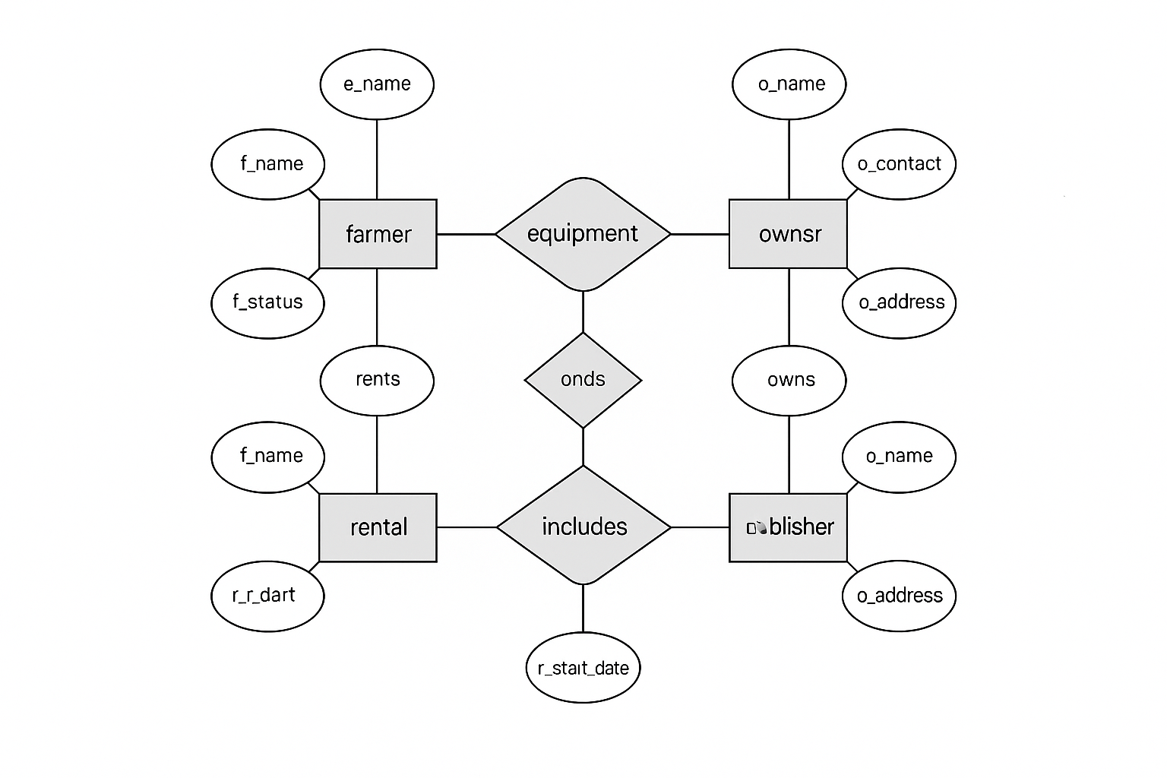

Data Flow Diagram (DFD):

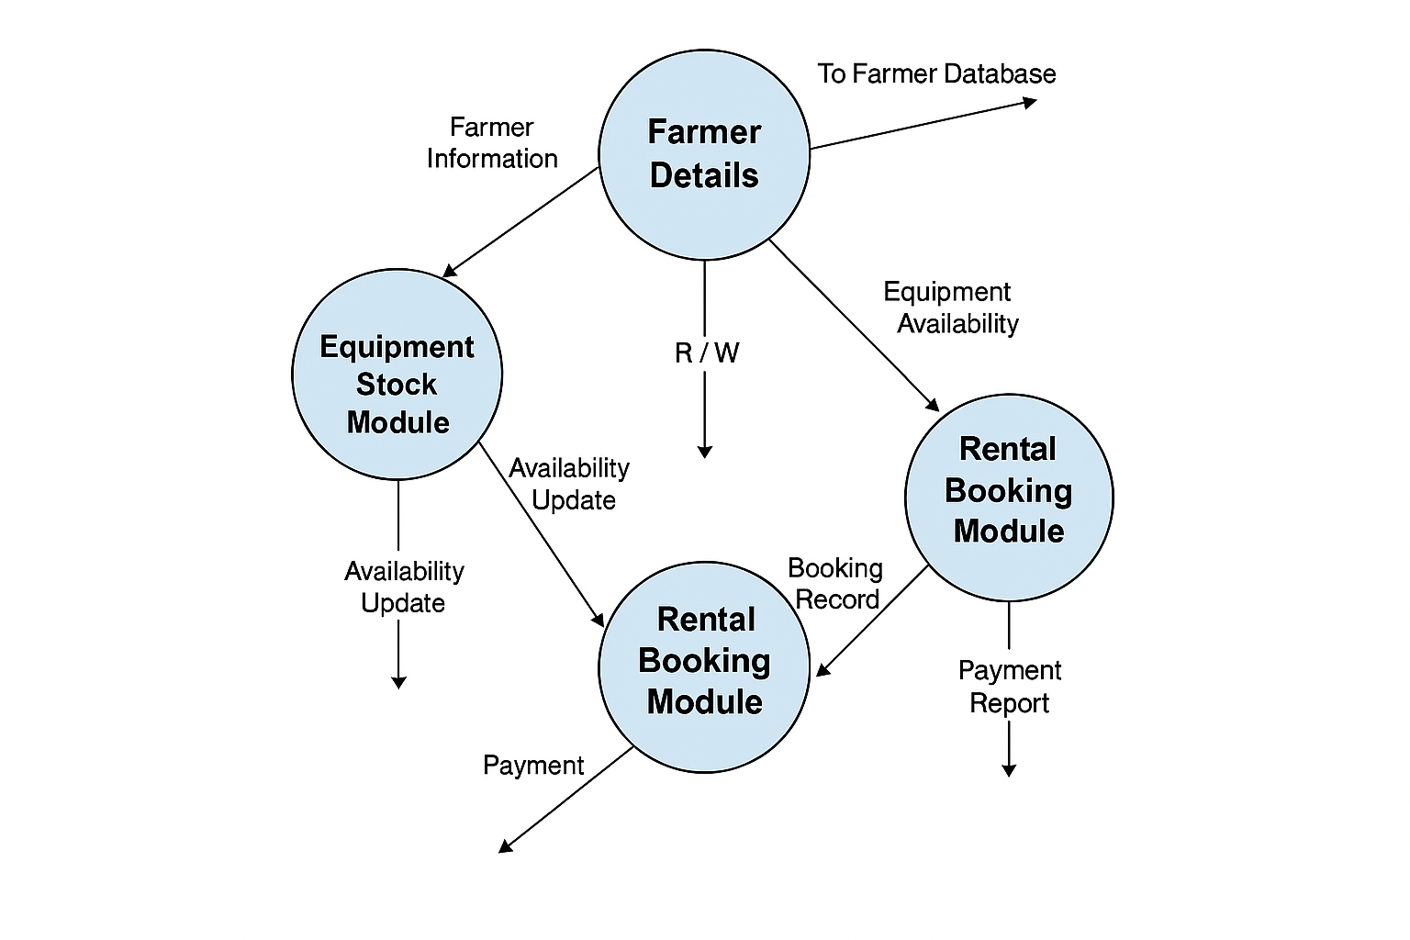

Conclusion:

The Agriculture Equipment Rental Management System is an online web application where farmers can rent agricultural equipment easily.
Through a web browser, users can search equipment based on type and availability.
Farmers can select required equipment and complete the booking process online.
This system helps save time and effort by avoiding physical visits to rental centers.

Bibliography -

Books–

• HTML & CSS: The Complete Reference, Fifth Edition
by Thomas A. Powell

• JavaScript & SQL: Web Database Applications
by Robin Nixon

Websites:
1.www.google.co.in
2.www.wikipedia.org
3.www.javatpoint.com
4.www.w3schools.com

